**City and Hackney Integrated Commissioning (IC) Programme Induction and Information Pack**

**An overview of the City and Hackney IC Programme for all staff including new starters.**

**Version 2**

**Revision – November 2019**

  

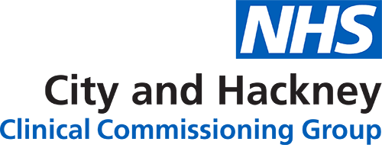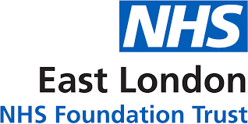

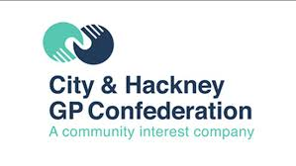 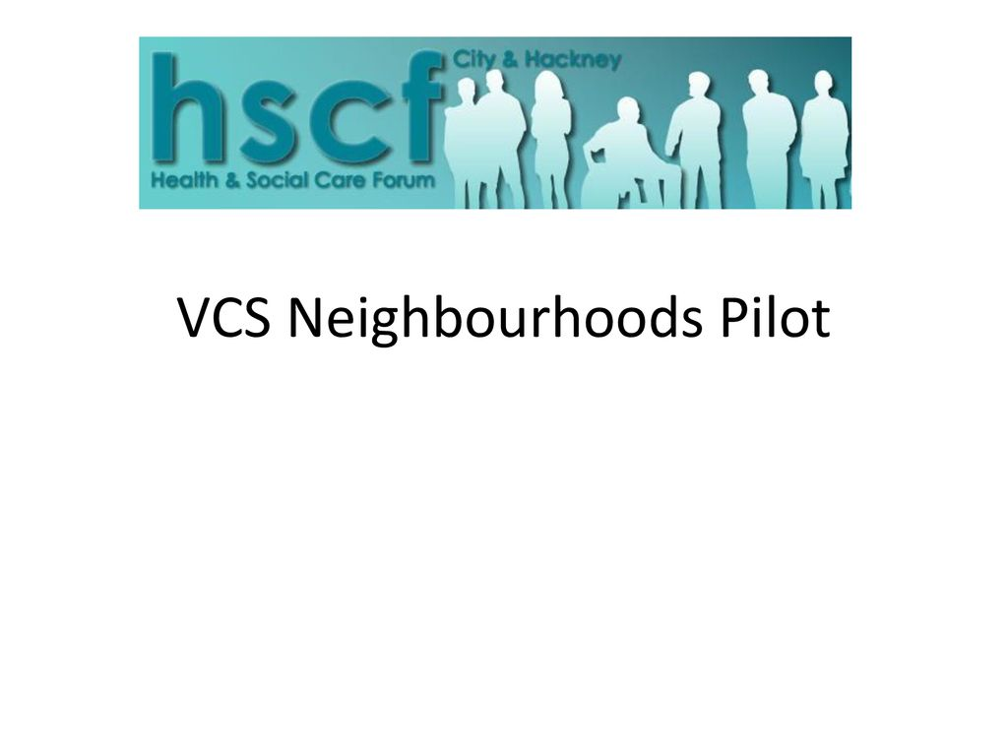 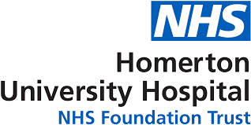

Contents

About this guide 4

Frequently used acronyms 5

The induction process for the IC Programme 6

North East London – Key Facts 7

Background to the City and Hackney IC Programme 8

Who is involved in the IC Programme? 9

The IC Programme strategic vision, objectives and values 10

**Our vision** 10

**Our strategic objectives** 10

**Our Values** 10

The IC Programme’s governance arrangements 11

The City and Hackney IC Programme Team & contacts 13

City and Hackney’s strategic programmes of work & key contacts 14

**The Neighbourhoods Programme** 14

**Primary Care Networks (PCNs)** 15

**The Making Every Contact Count (MECC) Programme** 15

IC Care Workstreams 16

**Overview** 16

**The Unplanned Care Workstream** 16

**The Planned Care Workstream** 17

**The Children, Young People, Maternity and Families (CYPMF) Care Workstream** 18

**The Prevention Workstream** 19

System Enabler Groups 20

Co-production with patients and staff 22

Further useful reading 23

# About this guide

This guide provides an introduction to the IC Programme in City and Hackney. It is for colleagues who want to learn more about the programme, and is specifically for those who are going to be joining the programme as employees. This document is designed to complement any induction materials provided by host organisations. Any formal induction (such as a new starter roadshow or induction day) will be arranged by the host organisation as per their usual on boarding processes.

By the end of this induction booklet colleagues should have a good understanding of the following:

North East London – Key Facts

The origins of the IC programme

The organisations involved in the IC programme

The IC programme’s strategic, Vision, Objectives and Values

The IC programme’s governance arrangements

Each of the four care workstream portfolio areas

The key strategic transformation programmes hosted by the programme

What work the IC care workstreams are responsible for delivering

How the programme is supported by the 5 system enabler groups

# Frequently used acronyms

Integrated Commissioning (IC)

Accountable Officers Group (AOG)

Integrated Commissioning Board (ICB)

London Borough of Hackney (LBH)

Corporation of the City of London (CoL)

City and Hackney Clinical Commissioning Group (CCG)

Homerton University Hospital (HUH)

GP Confederation (GPC)

East London Foundation Trust (ELFT)

City and Hackney (C&H)

North East London (NEL)

Sustainability and Transformation Partnerships (STP)

Senior Responsible Officer (SRO)

East London Health Care Partnership (ELHCP)

NHS Long Term Plan (LTP)

# The induction process for the IC Programme

Your induction will be structured as follows:

1. **Before you start with us**

Pre reading around the programme:

All papers from the Integrated Commissioning Board (ICB) can be located by clicking the hyperlink < [here](http://www.cityandhackneyccg.nhs.uk/about-us/integrated-commissioning-board.htm) >

Additional relevant reading around related agendas, including the NHS Long Term Plan can be found on page 23

Additional reading may be provided by your Induction Manager (this will be either the IC Programme Director or one of the Care Workstream Directors)

**2) Once you have started with us**

Meet contacts across the IC Programme

Your Induction Manager will provide steer around who from across the system you should meet with; role summaries and contact details, are embedded throughout this document

**If you have queries, please contact:**

The Director of Programme Delivery

Dr Carolyn Kus: c.kus@nhs.net

# North East London – Key Facts

Collectively the local systems in North East London are working to a shared vision for health and care with the aim to work together as a joined-up health and care system. To drive this, is the establishment of the North East London Commissioning Alliance (NELCA) and East London Health and Care Partnership (ELHCP) and the development of a high-level common framework for integrated care delivery and planning.

The Partnership includes the NHS commissioning organisations within the North East London Commissioning Alliance (the seven Clinical Commissioning Groups), NHS provider Trusts (Barts Health, Barking, Havering & Redbridge University Hospitals Trust, the Homerton University Hospital Trust, East London Foundation Trust and North East London Foundation Trust), the GP federations and the eight local authorities.

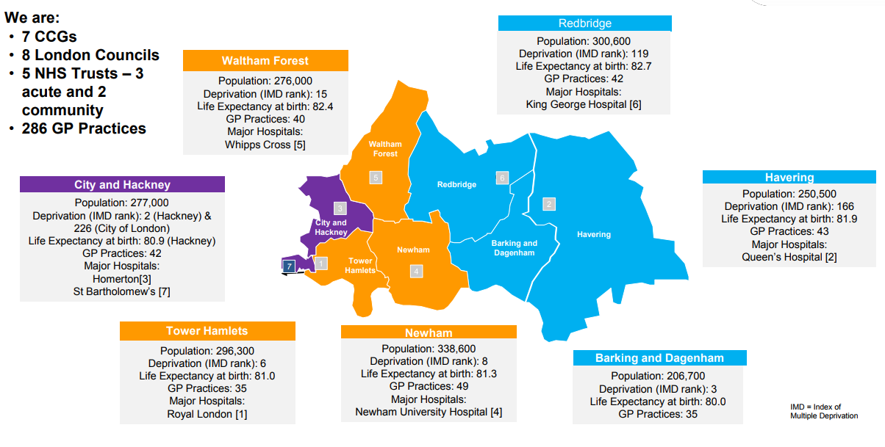

**Integrated Care in North East London: a visual representation**

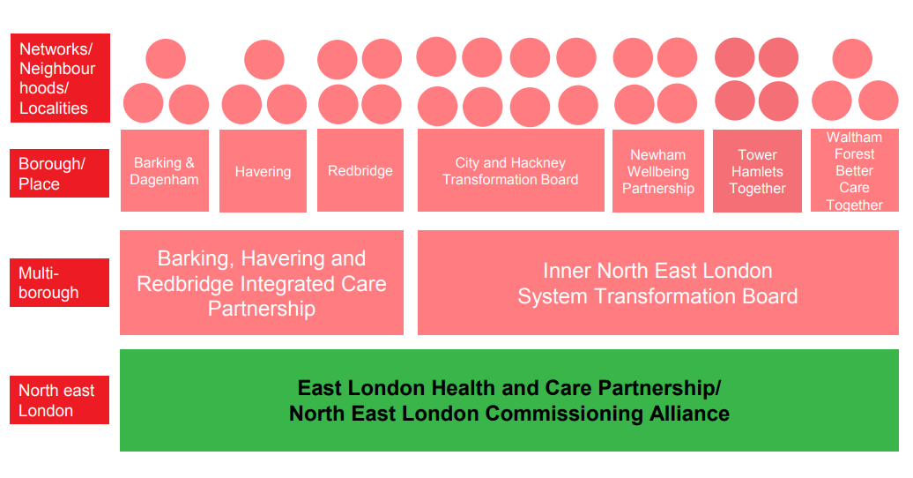

# Background to the City and Hackney IC Programme

In 2014, System leaders from across health and social care in City and Hackney came together to work towards a shared ambition - to improve health and care outcomes for local people within the context of growing patient/resident demand and the reduction of available resources.

The Hackney Leadership Summit was established in the summer of 2014 to collectively address these issues, and combat other issues, the Summit allowed leaders to have open and difficult conversations about the sustainability of the health and social care system locally and develop strong relationships.

Partners concluded that ‘Devolution’ provided the best opportunity to address system challenges; and in 2016, partners jointly submitted a successful bid for Hackney [the City joined later] to become a pilot area for Devolution. Devolution has since evolved into ‘integration’, and in 2016, the IC programme was formally established to deliver ambitions for a more integrated health and care system in City and Hackney.

Since 2016, we continue to strengthen the joint working between our partners and service providers to improve the health and wellbeing outcomes for our residents and reduce health inequalities.

In 2019, NHS England published its Long Term Plan (LTP), setting out plans for all national health systems to work in ‘Integrated Care Systems’. The plan set out a timetable for establishing Integrated Care Systems (ICS) by April 2021 and typically the setting up of 'a single CCG for each ICS area‘. The City and Hackney IC programme have contributed to the North East London’s (NEL) Integrated Care System (ICS) response to the Long-term plan. [Further information on the NEL STP is on (p.6)].

Links to further information on Devolution, the Long Term Plan and STPs can be found in ‘Further Reading’ on (p.23).

# Who is involved in the IC Programme?

The following organisations are involved in the IC programme

|  |  |
| --- | --- |
| Who | How are they involved? |
| Commissioners   * The London Borough of Hackney * Corporation of the City of London * NHS City and Hackney Clinical Commissioning Group | The three commissioning organisations have pooled and aligned funds in a Section 75 agreement, forming the basis of the programme.  Senior Leaders across each partner organisations sit across IC governance and act as Senior Responsible Officers on our care workstreams. |
| Providers [including the Voluntary Sector]   * NHS East London Foundation Trust ] * City and Hackney GP Confederation * NHS Homerton University Hospital Foundation Trust * City and Hackney Local Pharmaceutical Committee * Schools and Children’s Centres * Hackney Centre for the Voluntary Sector * A range of local voluntary and community organisations | Provider organisations across the City and Hackney health system have been involved in the programme from the start, and have supported us in shaping the IC programme and its strategic operations & vision.  Senior Leaders, practitioners, clinicians and voluntary sector reps from across each provider sit across IC governance, and act as Senior Responsible Officers on our care workstreams. |
| Represent the views of our patients:   * Healthwatch City of London * Healthwatch Hackney | The IC programme is committed to ensuring that patients are involved in all programme activities.  We work with City and Hackney Healthwatch organisations to recruit patients to the programme & provide them with ongoing support.  Patient and service user reps sit across all areas of IC governance. |
| Working with the North East London (NEL) Sustainability Transformation Partnerships   * Nationally, regional groups of CCGs, Local Authorities and other health and social care partners work in Integrated Care Systems called Sustainability and Transformation Partnerships (STPs) * One operates at the North East London (NEL) Level, the ‘East London Health and Care Partnership (ELHCP)’ works strategically with 12 local NHS organisations (commissioners and providers) and 8 local councils across NEL | For further information on STPs: <https://www.england.nhs.uk/integratedcare/stps/>  For further information on ELHCP: <http://eastlondonhcp.nhs.uk/>  City and Hackney is part of the NEL STP. As a programme, the ELHCP is provided with monthly programme updates. |

# The IC Programme strategic vision, objectives and values

Our programme vision, objectives and values have been developed through extensive consultation and input from those who are involved in the programme, our residents and patients.

## **Our vision**

Our vision is to work in a collegiate and integrated way to support people and their families to live the healthiest lives possible, and ensure they receive the right care when they need it - our vision will see us build a system which provides:

* **More support** for patients and their families to get healthy, stay well and be as independent as possible​
* **Neighbourhoods** where people and communities are actively supported to help themselves and each other
* **Joined up support** that meets the physical, mental  and other needs of patients and their families
* **High quality** GP practices, pharmacies and community services that offer patients more support closer to home
* **Thriving local hospitals** for patients when they need them.

## **Our strategic objectives**

We have developed five strategic programme objectives which will help us deliver the objectives set out in our vision:

* **Deliver a shift in resource and focus to prevention** to improve the long term health and wellbeing of local people and address health inequalities
* **Deliver proactive community based care** closer to home and outside of institutional settings where appropriate
* **Ensure we maintain financial balance** as a system and achieve our financial plans
* **Deliver integrated care** which meets the physical, mental health and social needs of our diverse communities
* **Empower patients and residents**

## **Our Values**

In running our programme, we will ensure we consider the following values at all times:

* **Listen to and involve** the public in everything we do
* **Recognise and value diversity** within our communities and our staff
* **Build on** local community assets and individuals’ strengths
* **Are honest** about the challenges and opportunities ahead
* **Encourage** staff and patients to be take responsibility for their actions and choices
* **Treat** staff, patients and partners across the health system with respect, compassion and dignity at all times
* **Act for the ‘system’ and the patient** rather than for the individual organisation.

# The IC Programme existing governance arrangements

We have structured the IC programme governance to ensure that partners across the system are involved in decision making at all levels. The voluntary sector, clinical and patient representatives are involved in most areas of our governance.

A diagram summarising governance arrangements is below:

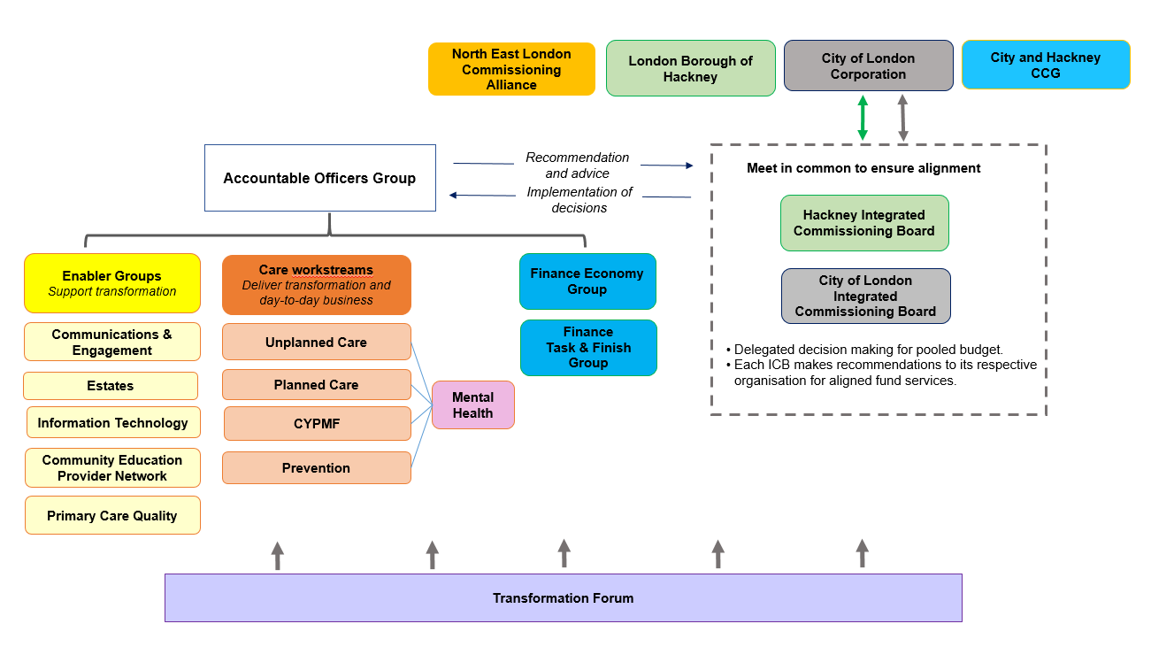

Below is a summary of what each governance area does and who it involves:

|  |  |
| --- | --- |
| Governance | Who is involved? |
| Integrated Commissioning Board (ICB) | The ICB functions as the IC programme’s ‘Partnership Board’: it sets the strategic vision of the IC programme and makes decisions on all services which are pooled and aligned as per City and Hackney's Section 75 Agreement.  It is attended by a broad composite of senior colleagues from across the City and Hackney health and social care system including Elected Members, Clinicians, and Chief Officers. It is also attended by the IC Programme Director and IC Convenor. |
| Accountable Officer Group (AOG) | The AOG is attended by the system leaders across the City and Hackney health and social care system, who are involved in the IC programme; including East London Foundation Trust (ELFT), the CCG, both local authorities- Corporation of the City of London (CoL) and the London Borough of Hackney (LBH), the GP Confederation and the Homerton Hospital.  It is also attended by the IC Programme Director and IC Convenor. The AOG have overall accountability for the IC programme and support the delivery of the ICB’s strategic vision for the programme, working from the IC Programme’s Single Operating Plan for 2019/20. |
| Transformation Board | The Transformation Board meets quarterly and is attended by a number of health and social care representatives across the City and Hackney system; including the voluntary sector, Healthwatch, and some provider organisations. The Forum also has patient representation.  The Board does not have any delegated authority and is asked to comment on / endorse rather than approve items. |
| Enabler Groups | Our five enabler groups support the transformation activities of our entire system, they cover the following key areas: Workforce (CEPN), IT, Estates, Communications & Engagement & Primary Care. |
| Care Workstreams  Care Workstream Delivery Groups | Our Care Workstreams are how we have arranged our services; each of our workstreams are responsible for delivering a programme of work across a specific portfolio area. Our four workstream areas include:   1. Unplanned Care 2. Planned Care 3. Children Young People Maternity and Families 4. Prevention   Each Care Workstream is managed by a Board or Core Leadership Group  Beneath each Care Workstream sits a network of delivery groups who support the delivery of workstream transformation and business as usual activities & objectives. |
| The Finance Economy Group (FEG)  The Finance Task and Finish Group (FTFG) | The FEG is responsible for the strategic financial management of the moneys pooled via the Section 75 Agreement (termed the ‘Integrated Commissioning Fund’), as set out in the Financial Framework. The FEG is attended by all Chief Financial Officers (CFOs) across the Partner organisations who have pooled funding.  The FTFG is comprised of the partner organisations’ deputy CFOs (or equivalent) and is responsible for the Integrated Commissioning Fund operational financial management and reporting. |

The City and Hackney IC Programme Team & contacts

IC Programme Team contacts are below. The Integrated Commissioning Governance Manager can provide full lists of the Members and attendees of the Transformation Forum and the ICB.

For full lists of the Members and attendees of each of the care workstreams, contact the relevant Transformation Support Officer.

|  |  |  |
| --- | --- | --- |
| **The Integrated Commissioning Programme Team** | | |
| Name | Job Title | Email |
| Dr Carolyn Kus | Director of Programme Delivery | c.kus@nhs.net |
| Carol Beckford | Interim Transition Programme Director | carol.beckford@nhs.net |
| Jonathan McShane | Integrated Commissioning -Programme Convenor | [jonathan.mcshane@nhs.net](mailto:jonathan.mcshane@nhs.net) |
| Stella Okonkwo | Programme Manager - Integrated Commissioning | stella.okonkwo@nhs.net |
| Alex Harris | Integrated Commissioning Governance Manager | [alex.harris2@nhs.net](mailto:alex.harris2@nhs.net) |
| Amaka Nnadi | Integrated Commissioning Finance Lead | [amaka.nnadi@nhs.net](mailto:amaka.nnadi@nhs.net) |
| Fiona Abiade | Integrated Commissioning Finance Project Manager | [fiona.abiade@nhs.net](mailto:fiona.abiade@nhs.net) |
| Faizal Mangera | System Financial Planning Lead | faizal.mangera@nhs.net |
| Jubada Akhtar-Arif | Programme Manager, Neighbourhood Health and Care Services | j.akhtar-arif@nhs.net |

The team is structured as per the below organogram:

City and Hackney’s strategic programmes of work & key contacts

In City and Hackney, we are running a number of strategic system-transformation programmes to integrate and personalise patient care, empower patients to manage their own health, and to provide care which is close to where patients live and work - some of the key initiatives outlined by the NHS’s Long Term Plan. These transformation programmes are hosted separately, but span all Workstream portfolio areas and interface closely with each other.

## **The Neighbourhoods Programme**

This programme is hosted by both the Planned and Unplanned Care Workstreams.

Hosted by the Planned Care Workstream, City and Hackney’s **Neighbourhoods Programme** aims to transform City and Hackney out-of-hospital community services including social care, mental health, whole-population primary care, acute urgent care, and GP out-of-hours services based in the community. The programme will see care providers working together to develop and deliver a service model.

Hosted by the Unplanned Care Workstream, City and Hackney’s **Neighbourhoods Programme** redesigns how care is provided to patients at both primary and community care level. The neighbourhoods programme structures the delivery of care through the eight Neighbourhoods across the borough, supported by multi-disciplinary teams who will use population-data to tailor the provision of care to the needs of their demographic area as well as deliver care closer to the patients’ home. The overarching aim being to ‘wrap around’ care in order to improve patient experience and outcomes. Neighbourhoods are co-located with Primary Care Networks (PCNs) – and the delivery of these programmes of work will be closely interlinked.

## **Primary Care Networks (PCNs)**

General practice is at the very heart of the NHS. The Long Term Plan requires Practices to come together to form Primary Care Networks in order to support their internal sustainability and resilience and to provide a solid primary care core and geography around which integrated services can be developed.

City and Hackney’s Primary Care Networks map directly on the existing Neighbourhood, which means there are eight PCNs with combined list sizes of between 33-57,000 patients. Each PCN is led by a nationally funded Clinical Director.

From July 2019, PCNs will collectively provide a national extended access service for their patients as well as employing part or wholly funded additional primary care staff made up of social prescribers and clinical pharmacists.

From April 2020, PCNs will employ more nationally funded staff (first contact physiotherapists and physician associates) and deliver nationally directed services such as anticipatory care. Richard Bull is the CCG’s lead for the internal sustainability and resilience of PCNS and Nina Griffith is the CCG’s lead for PCNs within an integrated care system.

## **The Making Every Contact Count (MECC) Programme**

Hosted by the Prevention Workstream. MECC aims to support and empower City and Hackney health and care staff to take advantage of every contact they have with patients - signposting them to local preventative services and other sources of wellbeing support. Over the coming years, training will be rolled out to staff across the system to develop their skill sets and build capacity. To ensure training is useful, appropriate, and the MECC approach is sustainable and embedded, the programme is being co-designed with residents and staff.

**Key Contacts for the Programmes**

|  |  |  |
| --- | --- | --- |
| **Neighbourhoods Health and Care Programme** | | |
| Name | System Role | Email |
| Jonathan McShane | Integrated Commissioning Programme Convenor | [jonathan.mcshane@nhs.net](mailto:jonathan.mcshane@nhs.net) |
| Jubada Akhtar-Arif | Programme Manager, Neighbourhood Health and Care Services | [j.akhtar-arif@nhs.net](mailto:j.akhtar-arif@nhs.net) |
|  |  |  |
| **Neighbourhoods Programme** | | |
| Steph Coughlin | Clinical Lead for Neighbourhoods | [stephaniecoughlin@nhs.net](mailto:stephaniecoughlin@nhs.net) |
| Mark Golledge | Neighbourhoods Programme Lead | mark.golledge1@nhs.net |
|  |  |  |
| **PCNs** | | |
| Richard Bull | Programme Director -Primary Care | [richardbull@nhs.net](mailto:richardbull@nhs.net) |
| Mark Rickets | Primary Care Clinical Lead | mark.rickets@nhs.net |
|  |  |  |
| **MECC** | | |
| Tamsin Briggs | MECC Programme Manager | [tamsin.briggs@hackney.gov.uk](mailto:tamsin.briggs@hackney.gov.uk) |

IC Care Workstreams

## **Overview**

As above, the IC programme has four care workstreams. Each Workstream is managed by a Board or Leadership Group and includes the following:

* A Senior Responsible Officer (SRO) who Chairs the Board
* A Programme Director
* One or more voluntary sector representatives
* One or more service user representatives
* Representatives from across the City and Hackney health and social care system

While **Mental health** and **Primary care** are not formal ‘workstreams’, their management and governance processes are similar to the above; mental health is managed through the Mental Health Co-ordination Committee; mental health interfaces with all of the care workstreams & key mental health delivery objectives are included in each of the individual Workstream narratives below. Primary care is managed via the Primary Care Enabler Group [further details on (p.20).

|  |  |  |
| --- | --- | --- |
| **Mental Health Co-ordinating Committee** | | |
| Name | System Role | Email |
| Dan Burningham | Mental Health Programme Director | [dan.burningham@nhs.net](mailto:dan.burningham@nhs.net) |
| Rhiannon England | Mental Health Clinical Lead | rhiannon.england@nhs.net |

## **The Unplanned Care Workstream**

The Unplanned Care Workstream is responsible for:

**Urgent care services** including Accident and Emergency (A&E) – specifically maintaining good performance and redirecting patients away from Homerton A&E to our Primary Urgent Care Centre (attached to the Homerton Hospital’s A&E department), and other services. We also explore ways to better support patients who attend A&E frequently (particularly those with mental health issues). Other urgent care activities include developing our 111 and ParaDoc services, and developing our primary care Out of Hours offer.

We are working to improve **Hospital Discharge** performance and processes through improved partnership working and developing new models of care – including our Discharge to Assess Pilot, which enable medically well patients to be discharged safely from hospital and have their assessment in the community.

We have recently developed an **Urgent End of Life Care Service**, which will give people more choice about which end - of - life care they receive and where they receive it. This service provides urgent support for patients at the end of life, on a 24 hour, 7 day a week basis.

We understand that many of our patients want to access **Dementia Care services** in the community closer to where they live – to support this we are developing a Community Dementia Service, and improving our Dementia Navigation service.

|  |  |  |
| --- | --- | --- |
| **Unplanned Care Workstream** | | |
| **Name** | **System Role** | **Email** |
| Nina Griffith | Unplanned Care Workstream Director | [nina.griffith@nhs.net](mailto:nina.griffith@nhs.net) |
| Tracey Fletcher | Unplanned Care Workstream SRO (Chair)  Note: Tracey is also Chief Executive Officer at HUHFT and sits on the AOG | [tracey.fletcher@nhs.net](mailto:tracey.fletcher@nhs.net) |
| Matt Hopkinson | Transformation Support Officer | [matthewhopkinson@nhs.net](mailto:matthewhopkinson@nhs.net) |
| Susan Bennett | Discharge Lead (Clinical) | [susan.bennett@hackney.gov.uk](mailto:susan.bennett@hackney.gov.uk) |
| Ben Molyneux | Urgent and end-of-life care Lead (Clinical) | [benmolyneux@nhs.net](mailto:benmolyneux@nhs.net) |
| May Cahill | CCG Clinical Representative | [m.cahill@nhs.net](mailto:m.cahill@nhs.net) |
| Ida Scoullos | Patient Representative | Ida.scoullos@gmail.com |

## **The Planned Care Workstream**

The Planned Care Workstream is responsible for:

City and Hackney’s **Outpatients Transformation Programme,** which will redesign City and Hackney Outpatient Services to improve patient access options, prevent unwarranted first attendances and referrals, reduce unnecessary routine face to face follow ups and will seek to optimise secondary and primary care working. The programme will develop digital access and operational solutions including digitalising referral pathways and providing improved digital access to clinical records for primary and secondary care clinicians.

City and Hackney’s local **Cancer transformation programme:** This programmereflects the City and Hackney’s ambition to stabilise cancer performance and consistently meet cancer targets. The key activities identified to progress this include - increased screening to support earlier detection and diagnosis of cancers at stage 1 and 2, implementing a GP led follow up service for men with prostate cancer, and running awareness raising programmes with community pharmacies. Other work to be undertaken include updating the number of clinical pathways for breast, lung, and colorectal cancers.

City and Hackney’s **Learning Disabilities Transformation Programme:** This programme aims to create a service which breaks down the barriers faced by people with learning disabilities and ensure that service transformation is structured around four key areas including Independence, Where I live, My community, My Health. The programme also includes specific projects to improve employment rates and health outcomes for people living with a learning disability.

Work is also underway to roll out **Personal Health Budgets (PHBs)** to patients including those who use HUH’s Wheelchair Service, those with established mental health issues, long-term conditions and some young people.

|  |  |  |
| --- | --- | --- |
| **Planned Care Workstream** | | |
| Name | System Role | Email |
| Siobhan Harper | Planned Care Workstream Director | [siobhanharper@nhs.net](mailto:siobhanharper@nhs.net) |
| Andrew Carter | Planned Care Workstream SRO (Chair)  [Note: Andrew is Chief Officer/Director Community & Children’s Services at CoL and sits on the Accountable Officers Group] | Andrew.Carter@cityoflondon.gov.uk |
| Tim Lee | Transformation Support Officer | [timothy.lee@hackney.gov.uk](mailto:timothy.lee@hackney.gov.uk) |
| Gary Marlowe | Clinical Representative | [gmarlowe@nhs.net](mailto:gmarlowe@nhs.net) |
| Michael Vidal | Patient Representative | michael.vidal1@nhs.net |
| Elspeth Williams | Patient Representative | elspeth.williams@nhs.net |

## 

## **The Children, Young People, Maternity and Families (CYPMF) Care Workstream**

The CYPMF Care Workstream is responsible for:

* **Maternity services**: includes all services for women from conception to post-partum care. This includes projects to ensure continuity of care for every woman to improve perinatal mental health support, our maternity ‘personalisation’ offer and to better support women from vulnerable groups through their pregnancy and into motherhood.
* **Services for children, young people and their families**: includes developing closer links between primary care and children’s community health; exploring how we approach Adverse Childhood Events in a useful and joined up way; exploring factors contributing to exclusions, and developing a new integrated health offer for our Looked After Children (LAC) and our Special Educational Needs and Disabilities (SEND) services.

City and Hackney report very good performance on their **Child Adolescent Mental Health Services (CAMHS)**. Some of our CAMHS objectives include increasing access rates, reducing waiting times for assessment and treatment, reducing self-harm, suicide, and youth offending rates, improving our ‘transitioning young adults’ offer, and better supporting young people with eating disorders. By 2020-21, we will have a mental health professional embedded in all City and Hackney schools.

The CYPMF Workstream will also be implementing legislative changes to safeguarding policy over 2019/20.

|  |  |  |
| --- | --- | --- |
| **CYPMF Care Workstream** | | |
| Name | System Role | Email |
| Amy Wilkinson | CYPMF Care Workstream Director | [amy.wilkinson@hackney.gov.uk](mailto:amy.wilkinson@hackney.gov.uk) |
| Anne Canning | CYPMF Workstream SRO (Chair)  Anne is Group Director Children, Adults and Community Health at LBH and sits on the AOG | [anne.canning@hackney.gov.uk](mailto:anne.canning@hackney.gov.uk) |
| Jenny Zienau | CYPMF Programme Manager | Jenny.zienau@hackney.gov.uk |
| Matt Hopkinson | Transformation Support Officer | [matthewhopkinson@nhs.net](mailto:matthewhopkinson@nhs.net) |
| Balvinder Duggal | Clinical Representative (Maternity) | [balvinder.duggal@nhs.net](mailto:balvinder.duggal@nhs.net) |
| Suki Francis | Clinical Representative | Suki.francis@nhs.net |
| Anne-Marie Dawkins | Patient Representative | [ammarie@hotmail.co.uk](mailto:ammarie@hotmail.co.uk) |

## **The Prevention Workstream**

The Prevention Workstream is responsible for:

* **Supporting patients to better manage their health and prevent illnesses** [including Long Term Conditions], improving health outcomes for a variety of vulnerable groups, improving sexual health outcomes, and developing Social Prescribing and navigation services across the City and Hackney system.
* **Preventing people developing health needs and becoming ‘patients’** is imperative to the preventative health agenda. Prevention are running number of programmes to reduce obesity, smoking rates and inequalities in smoking prevalence across the City and Hackney population, these include providing the high quality smoking cessation and education services, services to help people get active and manage their weight, and services to help people manage their relationships with alcohol.

Systems and processes to **support patients to better manage their health**, include developing an integrated approach to increasing the uptake NHS Health Checks, managing Long Term Conditions more effectively in primary care [building on our already positive performance in this area], and implementing a new sexual health service model. The Prevention workstream also works closely with the CYPMF Workstream to support increased immunisation rates for both children and adults across the borough. We seek to increase social prescribing and care navigation in the community.

Partnering with other workstreams, Prevention will support projects to **improve outcomes for vulnerable groups** including work to develop preventative pathways for patients with complex needs [including substance misuse, mental health and homelessness], and improve employment rates for those with learning disabilities, mental health issues and better identify and support cares.

|  |  |  |
| --- | --- | --- |
| **Prevention Care Workstream** | | |
| Name | System Role | Email |
| Jayne Taylor | Prevention Care Workstream Director | [jayne.taylor@hackney.gov.uk](mailto:jayne.taylor@hackney.gov.uk) |
| Sandra Husbands | Prevention Workstream SRO (Chair)  Director Public Health for City and Hackney | sandra.husbands@hackney.gov.uk |
| Kate Wignall | Prevention Programme Manager | kate.wignall@hackney.gov.uk |
| Tim Lee | Transformation Support Officer | [timothy.lee@hackney.gov.uk](mailto:timothy.lee@hackney.gov.uk) |
| Nicole Klynman | Clinical Representative | [Nicole.Klynman@Hackney.gov.uk](mailto:Nicole.Klynman@Hackney.gov.uk) |
| Clare Highton | Clinical Representative | clare.highton@nhs.net |
| Ida Scoullos | Resident Representative | [ida.scoullos@gmail.com](mailto:ida.scoullos@gmail.com) |
| TBC | Resident Representative |  |

System Enabler Groups

The IC programme and the health and social care system in City and Hackney is supported by a network of system enabler groups who provide bespoke support for transformation activities in specific areas. Further details about each of the enabler groups is below:

|  |  |  |
| --- | --- | --- |
| **Enabler Group** | **Key areas of work** | **Key personnel** |
| **Estates Enabler Group**  Supports the development of a local Estates Plan to make the best use of the estate (NHS and public sector), this Groups works with the wider North East London STP Plan | * LBH’s Estates redevelopment * Leading on the development of the C&H Estates Strategy including Primary Care Estates * Supporting work to determine how C&H Estates can support the Neighbourhoods Programme | Chaired by Sunil Thakker, Director of Finance at the CCG  And Co- Chaired Ian Williams, Director of Finance and Corporate Resources at LBH |
| **The Primary Care Enabler Group**  Supports the delivery of high quality, resilient and sustainable primary care | * Developing our Primary Care Contract * Supporting GP IT activities | Chaired by Mark Rickets, Chair of the CCG,  Managed by Richard Bull, Director of Primary Care at the CCG |
| **The Comms and Engagement Enabler Group**  Ensuring that patients and service users are involved in the IC programme, that all programme activities are in line with the Co-production Charter [further information on (p.17)], and that everyone who lives in City and Hackney is kept informed about the programme. | * Lead communications about, and support events to, promote the IC programme to system staff, residents and patients * Ensure the IC programme Co-Production Charter is embedded * Support and recruit patient representatives | Joint chaired by Catherine Macadam, a Lay Member with the CCG and Jon Williams, Director at Healthwatch Hackney  Managed by Jamal Wallace, Engagement and Coproduction Manager at Healthwatch Hackney. |
| **The IT Enabler Group**  Supports the implementation of digital solutions that support the development of new models of care across the IC programme | * Supporting the development of key areas of work such as the Planned Care Outpatients Transformation, the Neighbourhoods, and Community Services Redesign programmes * Support with Digitalisation initiatives across the system, particularly in Primary Care as per LTP requirements | Chaired by Tracey Fletcher, HUH CEO, Tracey is also SRO of the Unplanned Care Workstream and sits on the AOG.  Managed by Anita Ghosh – IT Enabler Programme Manager. |
| **The Workforce Enabler Group (CEPN)**  Supports workforce development to meet the needs of the City and Hackney community, whilst addressing the challenges of the health and social care workforce | * Training Practice Managers and supporting the recruitment and retention of GPs across the system * Supporting initiatives to strengthen the Neighbourhood and Primary Care Network development * Facilitating Clinical Practitioner Forums | Chaired by Deborah Colvin, City and Hackney GP Confederation.  Senior Responsible Officer – Laura Sharpe,  CEO, City and Hackney GP Confederation. |

Contact details for key liaison personnel on the enabler groups is below:

|  |  |  |
| --- | --- | --- |
| **Enabler Group contacts** | | |
| Enabler Group | Name | Email |
| Workforce | Grace Neal | grace.neal@nhs.net |
| Primary Care | Richard Bull | [richardbull@nhs.net](mailto:richardbull@nhs.net) |
| IT | Anita Ghosh | a.ghosh1@nhs.net |
| James Driver | [james.driver@nhs.net](mailto:james.driver@nhs.net) |
| Estates | Amaka Nnadi | amaka.nnadi@nhs.net |
| Jo Coolie | [jo.coolie@hackney.gov.uk](mailto:jo.coolie@hackney.gov.uk) |
| Communications and Engagement | Jamal Wallace | jamal@healthwatchhackney.co.uk |
| Alice Beard | alice.beard@hackney.gov.uk |

**Key contacts across the partner organisations within the City and Hackney IC system**

The key contacts from each of the partner organisations involved in the IC programme have been identified below; these colleagues regularly interface with the IC programme and its governance:

|  |  |  |
| --- | --- | --- |
| **Key Contacts from each of the system organisation** | | |
| Name | Host organisation & role | Email |
| Ellie Ward | Interim Head of Strategy and Performance, Corporation of the City of London CoL | [Ellie.Ward@cityoflondon.gov.uk](mailto:Ellie.Ward@cityoflondon.gov.uk) |
| Sallie Rumbold | Head of Integration, The Homerton Hospital | [sallie.rumbold1@nhs.net](mailto:sallie.rumbold1@nhs.net) |
| Richard Fradgley | Director of Integrated Care, ELFT | [rfradgley@nhs.net](mailto:rfradgley@nhs.net) |
| Laura Sharpe GP Confederation | CEO, City and Hackney GP Confederation | [laura.sharpe1@nhs.net](mailto:laura.sharpe1@nhs.net) |
| Jackie Brett | Director of Programmes & VCS strategy, Hackney Centre for the Voluntary Sector | [Jackie.Brett@hcvs.org.uk](mailto:Jackie.Brett@hcvs.org.uk) |
| Tessa Cole | Head of Strategic Programmes and Governance, LBH | [tessa.cole@hackney.gov.uk](mailto:tessa.cole@hackney.gov.uk) |

Co-production with patients and staff

The IC programme is committed to co-producing its outputs and activities with residents, patients and staff. In 2017, we developed a Co-Production Charter, which all areas of the programme adhere to in their activities; this document defines Co-production as ‘designing, reshaping or delivering services in equal partnership with the people who use them in order to create better services and outcomes’.

Some key tenets of our Co-production approach see us endeavouring to involve people who *use* or are *impacted by* a particular service or proposal rather than more general patient reference groups to make sure the people who are impacted most are given an opportunity to share their thoughts and help make improvements. We have designed our governance to ensure that patient and public representatives are involved at all levels of the IC programme’s decision making processes, we value them as equal members of any group or Board and provide training and support for representatives involved in the programme.

For further information on our co-production charter can be accessed here <[link](http://www.cityandhackneyccg.nhs.uk/about-us/coproduction-charter.htm)>:

# Further useful reading

The Devolution Programme

The Mayor’s Office Devolution Briefing Page

<https://www.london.gov.uk/what-we-do/health/london-health-and-care-devolution>

The NHS Long Term Plan

The NHS Long Term Plan document – a summary paper can be accessed from this page

[www.longtermplan.nhs.uk/](http://www.longtermplan.nhs.uk/)

The Kings Fund LTP Summary Paper

[www.kingsfund.org.uk/publications/nhs-long-term-plan-explained](http://www.kingsfund.org.uk/publications/nhs-long-term-plan-explained)

Sustainability Transformation Partnership (STPs)

The NHS England information page on STPs

<https://www.england.nhs.uk/integratedcare/stps/>

The North East London STP, The East London Health and Care Partnership page

<http://eastlondonhcp.nhs.uk/>

Integrated Care

The Kings Fund Integrated Care page

[www.kingsfund.org.uk/topics/integrated-care](http://www.kingsfund.org.uk/topics/integrated-care)

NHS England’s Integrated Care page

[www.england.nhs.uk/ourwork/part-rel/transformation-fund/](http://www.england.nhs.uk/ourwork/part-rel/transformation-fund/)

Health Education England’s Integrated Care page

[www.hee.nhs.uk/our-work/integrated-care](http://www.hee.nhs.uk/our-work/integrated-care)

Integrated Care overview from the Nuffield Trust

[www.nuffieldtrust.org.uk/files/2017-01/what-is-integrated-care-report-web-final.pdf](http://www.nuffieldtrust.org.uk/files/2017-01/what-is-integrated-care-report-web-final.pdf)

**Document Revision**

|  |  |  |
| --- | --- | --- |
| ***Version*** | ***Date*** | ***Update by*** |
| V1 | 16/08/2019 | Stella Okonkwo: Programme Manager – Integrated Commissioning stella.okonkwo@nhs.net |
| V2 | 20/11/2019 | Stella Okonkwo: Programme Manager – Integrated Commissioning stella.okonkwo@nhs.net |
|  |  |  |
|  |  |  |
|  |  |  |