Overview of Adult Services - Service structure

Below is a structure chart of Adult Social Services and a summary of the different services in Adult Services.
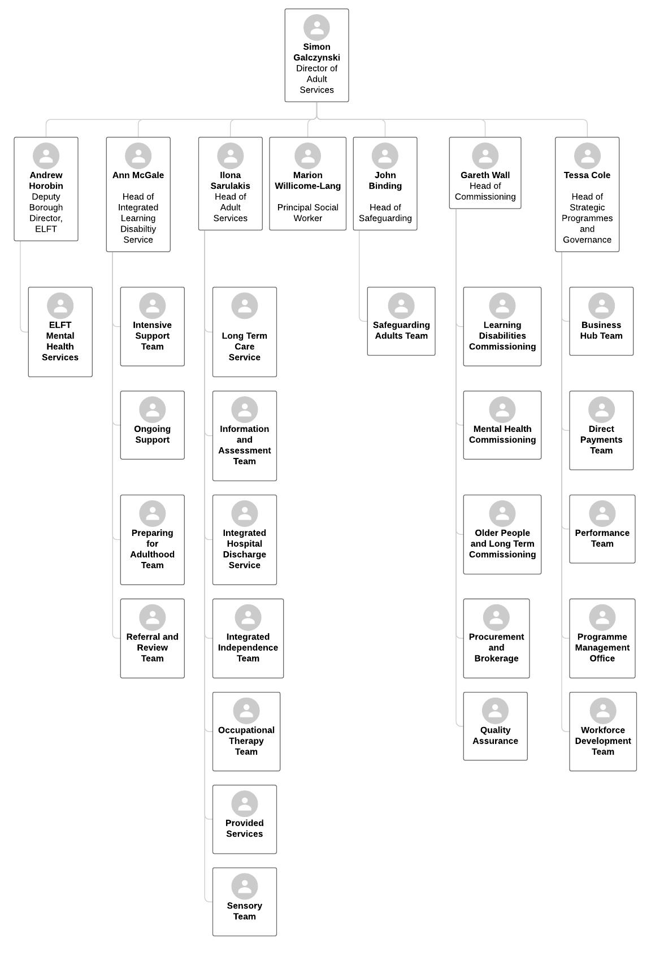

Hackney Adult Services operates an integrated model of care and support and many of our teams are made up of multi-disciplinary professionals including Social Workers, Occupational Therapists, Assessment and Review officers, Occupational Therapy Assistants and health professionals from the NHS.
Adult Social Care – Head of Service: Ilona Sarulakis
Access points into Adult Social Care comprise of two key teams; the Information and Assessment Team and the Integrated Hospital Discharge Service.
Information and Assessment Team
The Information and Assessment Team is the main point of contact for Hackney residents over the age of 18 who want to make general enquiries about adult social care services and community-based support.
The team provides information and advice to residents, completes initial assessments for anyone not already in receipt of a social care service and signposts on to other services where that is appropriate.
The team also determines whether a resident is eligible for Council funded support through the completion of a Care Act Assessment and follow up any safeguarding concerns of abuse or neglect.
Integrated Hospital Discharge Service
The Integrated Hospital Discharge Service is an alternative first point of contact for those residents who are in hospital. This service is based at the Homerton University Hospital and includes Social Workers, Discharge Co-ordinators and the Continuing Healthcare (CHC) Team as part of a multi-disciplinary approach to assessing people for their eligibility for adult service or CHC support prior to their discharge from hospital and signposting them to voluntary and third sector agencies where that is more appropriate.
Although the majority of people they support are at the Homerton, they also work with any acute ward where Hackney residents are based and with other local authorities to facilitate the discharge of non-Hackney residents from the Homerton.
Following an assessment, residents access a range of prevention and reablement services designed to keep them living as independently as possible.
Integrated Independence Team
The first of these is the Integrated Independence Team (IIT). This is a multi-disciplinary team including Social Workers, Occupational Therapists, Physiotherapists, Geriatricians, Speech and Language Therapists, Nurses and Independent Assistants.
It integrates intermediate care and reablement services to provide a streamlined approach to promoting independence through reablement support for up to six weeks and preventing unnecessary hospital admissions.
Occupational Therapy Service
The Occupational Therapy Service works with people with physical impairments and their carers to maintain and reduce their care needs by providing early interventions – carrying out assessments and by providing advice, support, equipment and adaptations to maximise their level of independence and wellbeing.
The Occupational Therapy Service is also responsible for Hackney’s Integrated Community Equipment Services (ICES), including Telecare. These services aim to maintain a person’s independence, prevent hospital admission and reduce care packages by them to live safely and securely.
Sensory Team
The final team that forms part of the prevention and reablement services is the Sensory Team. This offers assessment and rehabilitation for adults with a sensory need, such as vision or hearing impairments, helping them to remain active and independent by access to education and community services.
Long Term Team
The Long Term Care Service works in partnership with older adults who have already been assessed for Council-funded support, their families, communities, other Council departments and other organisations including the health and the voluntary sector.
The service includes Social Workers and Review officers and is responsible for completing Care Act assessments, support plans and reviews for older people who do not have a mental health condition or a diagnosed learning disability. The service helps people living at home to access community-based services, or supports their transfer into Housing with Care, Residential Care or a Nursing Care settings.

Adult Safeguarding Team
Over-arching the entire social care pathway is the Safeguarding Adults / Deprivation of Liberty Safeguards (DoLs) Team. This team provides support, advice and guidance in relation to adult safeguarding, the Mental Capacity Act 2005 and DoLS to all Adult Social Care teams and strategic partners across the borough. It also supports Social Workers with any high risk and complex cases and acts as the supervisory body for DoLS authorisations in care homes and hospitals.

Provided Services
Provided Services is the Hackney’s in-house provision of care services. It includes Housing with Care, Oswald Street Day Service and its associated transport, and the Homeshare Daycare Scheme. Housing with Care is aimed at adults over the age of 55 years whilst Oswald Street and the Homeshare Daycare Scheme are for people over the age of 18. People who use these services include older people, people with learning disabilities, people with dementia and people with physical disabilities. Additionally Housing with Care also supports some people with mental health problems with a social care need.
Hackney Shared Lives Scheme provides accommodation services for vulnerable adults. We recruit, assess, support and train people who live in the borough to become carers. We “match” the vulnerable person with the carer, thus enabling them to live in the community and enjoy the support that this unique relationship brings. Placements can be short term, respite, long term and we can be flexible with any request.

Integrated Learning Disabilities Services – Head of Service: Ann McGale
The Integrated Learning Disabilities Service is a multi-disciplinary service including Social Workers, Psychologists, Psychiatrists, and Speech and Language Therapists. It is jointly commissioned by the council and the CCG.
The team carries out care act assessments, reviews, and specialist interventions and support for adults who have a diagnosed learning disability residents to enable them to live well, remain mobile and to learning new skills. The service is responsible for supporting their transition from young people services into adulthood, for providing advice about aids and adaptations and for integrating social care support with psychological, psychiatric and behavioural interventions.
The service is jointly commissioned by the council and the clinical commissioning group and jointly provided by the council and the East London Foundation Trust.
Mental Health Services – East London Foundation Trust
All Mental Health services are provided by East London Foundation Trust but they have a dotted line into the council to ensure join up with social care services.
The Mental Health Care of Older People (MHCOP) is a multi-disciplinary team that includes Social Workers, mental health nurses, Occupational Therapists, Psychologists, Psychiatrists and support workers. It works with service users, carers and family members to provide health and wellbeing support for residents aged over 65 and for any adult presenting with older adult needs e.g. memory impairment.
It has two integrated community teams, the Community Mental Health Team for Older People (CMHT-OP) and the Dementia Care Team (DCT), providing psychiatric and social needs assessments and reviews, interventions and treatments for service users and carers. Amongst the services it co-ordinates are integrated memory assessment services, community dementia services, Nursing Home support and carer education and support.
Commissioning – Head of Service: Gareth Wall
The Adult Services Commissioning team commissions and contract manages all the major contracts for Adult Services which includes:
- Home care
- Residential and nursing care
- Advocacy services
- Carers services
- Housing related support
- Equipment and telecare services
- Domestic violence refuges
- Lunch clubs
- Targeted Preventative Services
- Home Improve agency for adaptations
This service also includes the Brokerage team who identifies and negotiates packages of care that have been assessed and presented by social work teams. In future we anticipate this will be taking on brokerage work on behalf of the NHS. There is also a quality assurance and compliance team which conducts site visits to provider organisations to make sure that service users are receiving quality of care that we would expect.
Strategic Programmes and Governance – Head of Service: Tessa Cole
This service provides key back office functions to support operational services to deliver effectively including:
- An expert Adult Social Care Performance Team
- A workforce development Team
- A business hub to deal with complaints, FOIs and members enquiries
- A Direct Payments team to work with residents to set up direct payments as a personalised way to manage their care
- A programme management office to provide the service with a structured approach to managing change projects

